**Literature Survey**

**Violence Detection in Video Using Computer Vision Techniques**

**Introduction**:

This survey addresses the underexplored domain of detecting fights and aggressive behaviours in video, contrasting with the prevalent focus on recognizing simpler actions like walking or waving. While action recognition techniques have made significant strides, their application to identifying violent actions remains limited. To bridge this gap, the study introduces a new dataset comprising 1000 video sequences categorized into fights and non-fights, with the objective of evaluating modern action recognition approaches for fight detection. Leveraging state-of-the-art descriptors such as STIP and Mo SIFT within the bag-of-words framework, the research achieves a high accuracy rate of nearly 90% in detecting fights, showcasing its potential utility in video surveillance scenarios, including prisons, psychiatric facilities, and elderly care centres. Additionally, the paper presents a novel dataset focused on hockey fights and demonstrates the effectiveness of the proposed methodology in accurately detecting violence in sports footage. These findings highlight the promising prospects for developing robust fight detection systems with applications in automated alert systems and online video content management.

**METHODOLOGY:**

1. **Bag-of-Words (BoW) Approach:**

The BoW approach, borrowed from the text retrieval domain, has gained popularity in image and video understanding. It represents video sequences as histograms over a set of visual words, obtained through techniques like k-means clustering of sample low-level descriptors such as STIP or MoSIFT. This approach enables the creation of fixed-dimensional encodings that can be processed using standard classifiers like Support Vector Machines (SVM). By quantizing descriptors extracted from videos to the closest visual words and classifying the resulting histograms, the BoW approach facilitates efficient and effective recognition of complex actions or events, such as violence in video sequences.

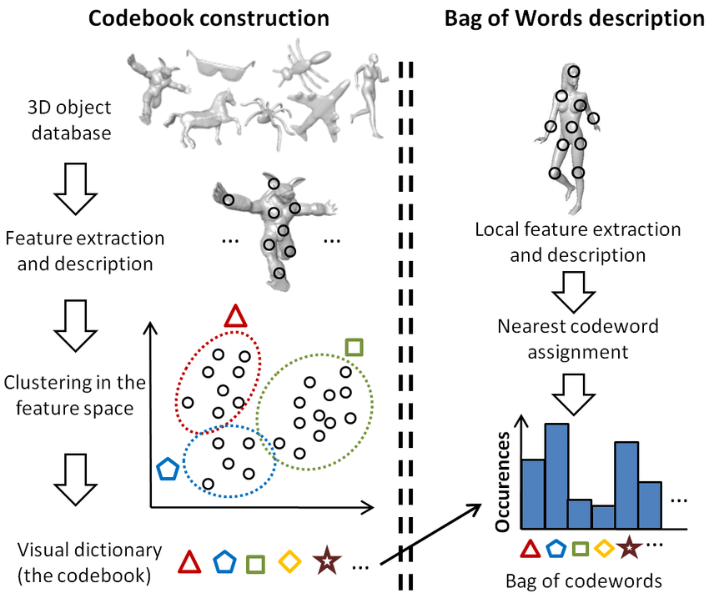

1. **Space-Time Interest Points (STIP) and Motion Scale-Invariant Feature Transform (MoSIFT):** These are prominent spatio-temporal descriptors used for activity recognition in videos. STIP extends the concept of interest points to space-time, detecting salient points characterized by intensity variation and non-constant motion. MoSIFT, on the other hand, enhances the popular SIFT image descriptor for video by incorporating histograms of optical flows to represent local motion. These descriptors enable the extraction of compact and descriptive representations of motion patterns in video sequences, essential for tasks like violence detection.

**SUMMARY OF FINDINGS:**

The study demonstrates the efficacy of modern spatio-temporal descriptors, namely Space-Time Interest Points (STIP) and Motion Scale-Invariant Feature Transform (MoSIFT), coupled with the bag-of-words (BoW) approach, in accurately detecting violent actions in video sequences. Leveraging a novel dataset comprising 1000 clips from NHL hockey games and an additional dataset from action movies, the study showcases the adaptability and robustness of the proposed violence detection systems across diverse scenarios. Results indicate near 90% accuracy levels in detecting fights, with MoSIFT outperforming STIP, particularly in action movie datasets.

**FUTURE SCOPE:**

Moving forward, the future of violence detection in video sequences holds promise for several advancements. One avenue for exploration lies in the refinement and integration of multi-modal features, encompassing both visual and auditory cues, to enhance the robustness and accuracy of detection systems. Additionally, the utilization of deep learning architectures, such as convolutional neural networks (CNNs) and recurrent neural networks (RNNs), presents opportunities for automatic feature learning and sequential modeling, potentially surpassing the performance of traditional handcrafted feature-based approaches. Moreover, the development of real-time violence detection systems capable of processing high-resolution video streams in resource-constrained environments remains a critical challenge, necessitating the optimization of algorithms for efficiency and scalability. Collaborative efforts towards creating standardized benchmarks and datasets for evaluating violence detection algorithms across diverse scenarios will also facilitate comparative analysis and foster advancements in the field. Ultimately, the integration of innovative methodologies and technologies holds the potential to significantly enhance the efficacy and applicability of violence detection systems in various domains, including surveillance, security, and content moderation.